Partner with the Air Force and Third Wave Systems to
Deliver Faster with Material-Specific Modeling Technology
Third Wave Systems (TWS) is looking for partners in the aerospace engine manufacturing supply chain to collaborate using the TWS suite of machining simulation technology to dramatically improve machining efficiency and reduce the cost of their production aerospace engine components, and to host a demonstration showcasing the collaboration benefits. The demonstration will enable a forum to expand customer outreach where the host company and TWS jointly demonstrate their capabilities to the government, prime manufacturers, and suppliers. Ideally, the host company will demonstrate a new and expanded capability, enabled by TWS, to win future business. Target improvements in this demonstration include:
- Dramatic reduction in machining time
- Improved tool life and tooling cost
- Scrap reduction
- Reduced part deflection
- Superior surface quality
- Elimination of subsequent operations
- CapEx avoidance
Recent Demonstration Achieved Outstanding Success
New England Airfoil Products (NEAP), as part of their digital transformation, integrated Third Wave Systems’ suite of experimentally validated, material-specific modeling and simulation technology to drive New Product Introduction (NPI) and continuous improvement. This integration was demonstrated in May of 2023 as part of a demonstration in TWS’ Air Force program.
Benefits from this innovation include:
- 50% reduction in machining time—increasing capacity and avoiding $800,000 in CapEx.
- Improved surface finish and quality—dramatically reducing labor for hand finishing.
- Achievement of first part-right through a 3x reduction in non-recurring programming time and elimination of machine trials and programming iterations.
NEAP's move to virtual prototyping for NPI and continuous-process improvement methodology delivered more, with less, much faster.
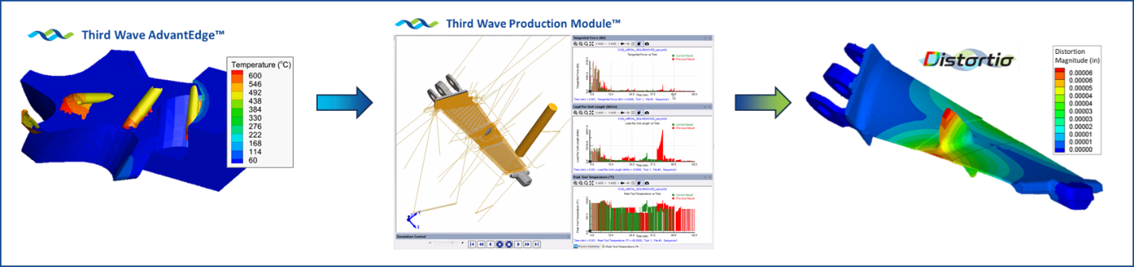

Solution: Advanced Modeling Technology
Recent advances in material-based modeling and simulation technology have enabled more efficient machining of traditional metal turbine engine parts, leading to a 50% reduction in machining costs. For example, applying state-of-the-art modeling technology to traditional turbine engine manufacturing has enabled significant increases in cutting speed and feeds, longer tool life, all resulting in better component manufacturing. Utilizing Third Wave Systems’ virtual prototyping suite of technologies has resulted in less downtime, removal of trial-and-error testing, and faster ramp up of new part production.
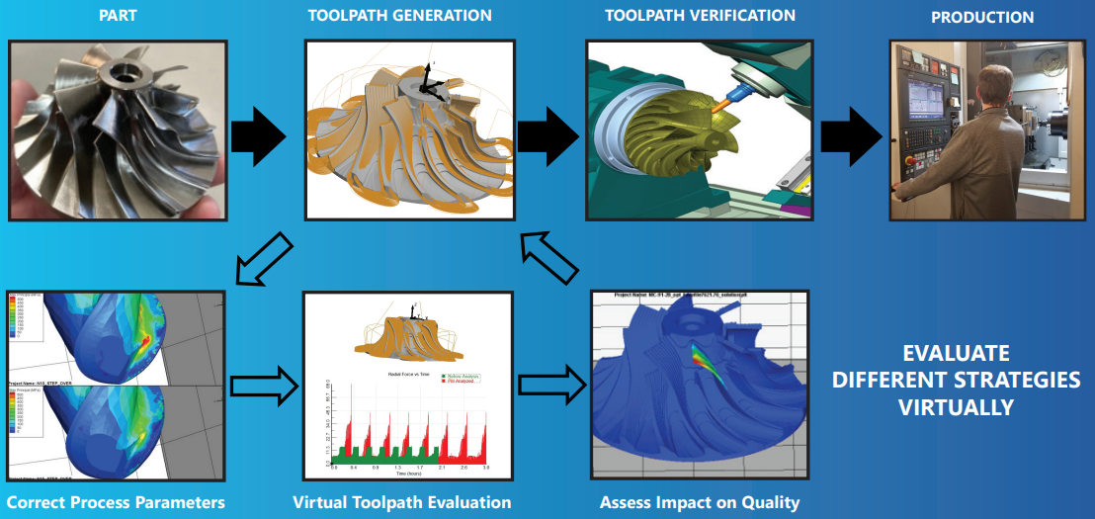
What it Takes to Become a Demonstration Partner
Location The Partner must have the capability and willingness to host guests from the government and the aerospace supplier base. The demonstration partner and TWS will identify and approve appropriate guests that may include engine OEM’s, Tier 1 suppliers, Tooling Manufacturers, and others.
Demonstration Part The ideal part is an aerospace engine component, preferably for a smaller size engine. TWS and the demonstration partner will work together to improve the machining process on the selected production part.

Roles and Responsibilities
Third Wave Systems | Demonstration Partner
Host a virtual kick-off  - Provide project summary to the demonstration partner and outline necessary files and part/process info  Attend the on-site meeting at the partner location  - To better understand the process and establish next steps  Work with demonstration partner engineers to dramatically improve (tailor) the process  - Train engineers on TWS technology and approach  - Work alongside engineers to select new tooling, CAM approaches, etc.  Assist in facilitating the on-site demonstration  - Work with demonstration partner to identify and invite attendees  - Create presentations and agenda  - Assist in validating the new processes  - Attend and co-host the demonstration | Provide part and process information to TWS  - Provide part CAD files and requirements  - Provide CAM files and tooling information to establish the baseline  - Provide machine tool information  Host an on-site meeting  - Host TWS engineers shortly after the kick-off to better understand the equipment, process constraints , etc.  Engineers work with TWS to dramatically improve machining processes  - Regular meetings with TWS to learn how to leverage all TWS technologies to reduce cost and improve part quality  Host an on-site demonstration for Air Force and other Government stakeholders, supplier base partners, and potential new customers  - Day-long meeting with presentation on the capabilities, approach, and success, and on-machine demonstration of the new process  - Work with TWS to identify and invite attendees  - On-machine validation of the new process prior to the demonstration

Program Summary: Modeling Technology for Small Turbine Engines
Air Force Program FA8650-20-C-5086
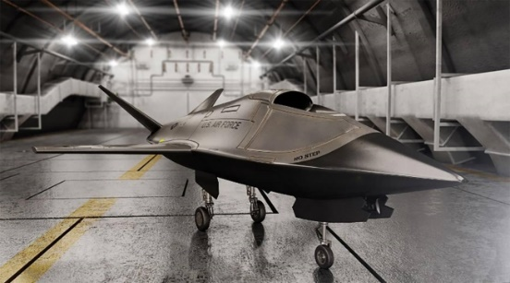
To support warfighter requirements for the increasing number and types of Unmanned Aircraft Systems (UAS), missile, long-range decoys and other air armament applications, the Air Force has an immediate need for affordable engines in the small and medium class (100-2000 pound thrust class). Small and medium turbine engines for systems such as Tomahawk Land Attack Missile (TLAM), the Air Force Research Lab’s (AFRL) Low Cost Attritable Aircraft Technology (LCAAT) initiative, and drone swarming technology must still be high-performance engines, and therefore require high-performance materials and precision machining and manufacture. Current manufacturing costs are too high to produce large volumes of these critical engines, or to use them in expendable roles.

